Student id s360785

RUNCHEN ZHANG

Introduction: Outline the objectives and requirements of the game and automated unit testing tool you will be using.

I found it difficult to split the whole game into sections that could be unit tested, so I tested the main logic of the game, the logic() function

I used the pytest tool

Process: You should clearly explain how TDD and automated unit testing tool have been used to create your program. Support it with relevant screenshots for each of the requirements.

First I pip installed pytest

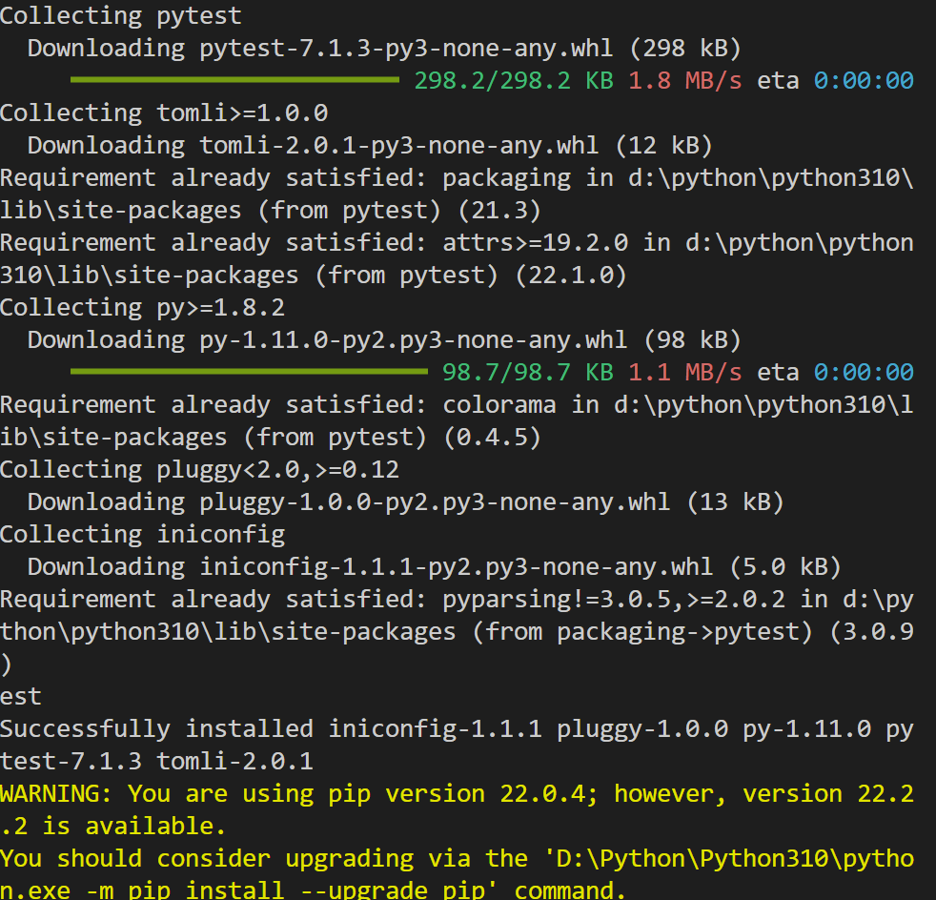

I then wrote a program to test the main function logic(), which determines the winner of the game and gives the corresponding score (1 or 0)

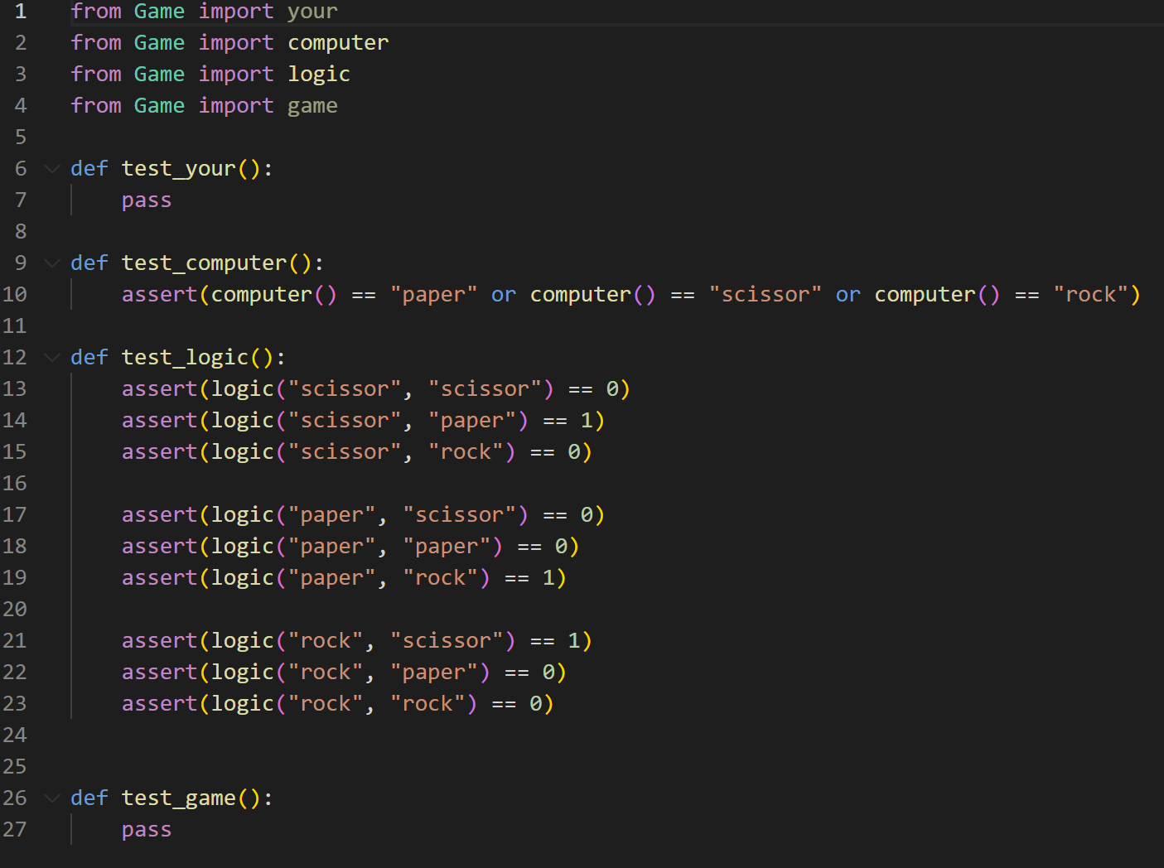

Finally, I ran the entire test file

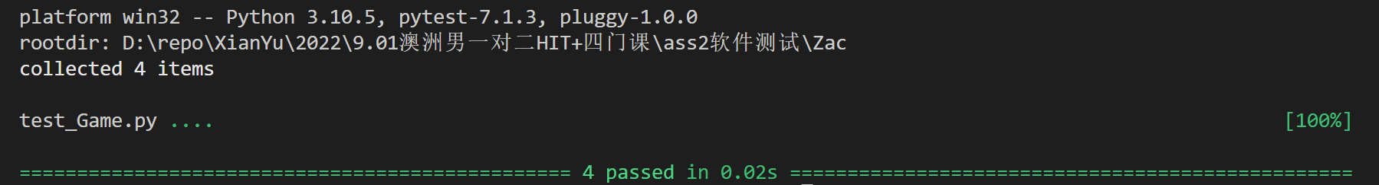

Conclusion: conclude the report with lessons learnt and your GitHub link.

I found that pytest does not support testing of print() and input(), so it becomes difficult to test games, which often use the input() function to interact with the user, and the print() function to prompt the user on the console

To make testing easier, I split up the functions and use return as the mainstay of the program

link: https://github.com/zac417/PRT582-s360785.git